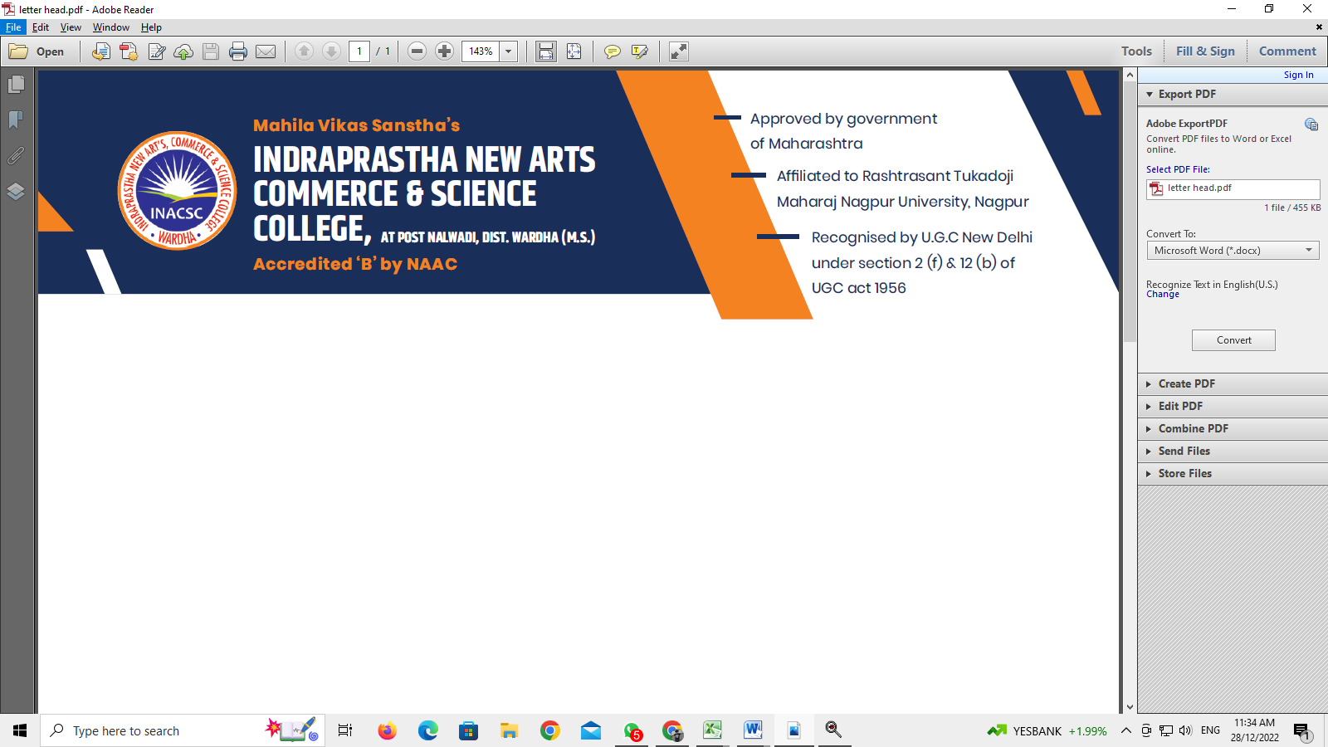

**DEPARTMENT OF BIOTECHNOLOGY**

**Question bank**

**BIOTECHNOLOGY**

**SEMESTER I**

**PAPER I: Microbiology**

**Long and Short Answer Questions**

1. Describe contribution of Louis Pasture in detail. 5M
2. Explain about acidic, basic and neutral stains. 5M
3. Explain in detail about endospores. 5M
4. Write a detailed note on cell cycle. 10M
5. Draw a well labelled diagram of typical bacterial cell with bacterial morphology. 10M
6. Describe brief idea about Bergeys Manual. 05M
7. Explain difference between selective and differential media. 10M
8. Explain in detail various phases of growth curve. 10M
9. Discuss the classification of micro-organisms on the basis of pH and temperature. 10M
10. Explain use and working of a chemostat. 05M
11. Describe temperature as a physical agent for microbial control.
12. Describe filtration as a method of microbial control. 10M
13. Describe any two chemical methods for microbial control. 05M
14. Describe the structure and functions of Golgi complex. 10M
15. Write a note on endoplasmic reticulum. 05M
16. What is lysosome? Explain its functions. 05M
17. Describe various stages of mitosis 10M
18. Write a note on neuromuscular junctions 05M
19. Write a detailed note on cell cycle. 10M
20. Define pure culture. 01M
21. What is synchronous culture. 01M
22. What is generation time? 01M
23. Explain in detail about endospores. 05M
24. Write a detailed note on cell cycle. 10M
25. Draw a well labelled diagram of typical bacterial cell with bacterial morphology. 10M
26. Describe brief idea about Bergeys Manual.
27. Explain difference between selective and differential media. 10M
28. Describe filtration as a method of microbial control. 10M
29. Describe any two chemical methods for microbial control. 05M
30. Describe the structure and functions of Golgi complex. 10M
31. Write a note on endoplasmic reticulum. 05M
32. What is lysosome? Explain its functions. 05M
33. Describe brief idea about Bergeys Manual. 05M
34. Explain difference between selective and differential media. 10M
35. Explain in detail various phases of growth curve. 10M
36. Discuss the classification of micro-organisms on the basis of pH. 05M

 **DEPARTMENT OF BIOTECHNOLOGY**

**Question bank**

**BIOTECHNOLOGY**

**SEMESTER I**

**PAPER II : Macromolecules**

1. Describe the detailed Watson and Crick Model of DNA. 05M
2. Concept of Slit gene write note. 02M
3. Write a short note on prokaryotic gene. 02M
4. Arrangement of histones in the octamer. 02M
5. Describe the primary structure of protein with end group analysis. 10M
6. What are amino acid? Describe the reaction of amino acids with Edmans reagent. 10M
7. Describes in detail the α-Helical and β-Plated sheet structure of proteins. 05M
8. Describe the forces that stabilize the tertiary structure of protein. 05M
9. Describe the titration curve of amino acid. 05M
10. Write a short note on c- value and c- value paradox. 02M
11. Write a short note telomere and centromere. 02M
12. Describe the domains with motifs and folds. 05M
13. Describe the secondary structure of protein. 05M
14. Add note on A and Z form of DNA. 05M
15. Give a detailed account of Maxam Gilbert Method of DNA sequencing. 10M
16. Describe in detail about Watson and crick model of DNA. 5M
17. Difference between prokaryotic gene and eukaryotic gene. 5M
18. Explain in detail classification of amino acid. 5M
19. Write down about quaternary structure of protein. 5M
20. Describes in detail the α-Helical and β-Plated sheet structure of proteins. 05M
21. Describe the forces that stabilize the tertiary structure of protein. 05M
22. Describe the titration curve of amino acid. 05M
23. Write a short note on c- value and c- value paradox. 02M
24. Write a short note telomere and centromere. 02M
25. Write a short note on prokaryotic gene. 02M
26. Arrangement of histones in the octamer. 02M

 **DEPARTMENT OF BIOTECHNOLOGY**

**Question bank**

**BIOTECHNOLOGY**

**SEMESTER II**

**PAPER I: Macromolecules Microbiology & Cell Biology**

1. Explain in detail various phases of growth curve. 10M
2. Discuss the classification of micro-organisms on the basis of pH and temperature. 10M
3. Explain use and working of a chemostat. 05M
4. Describe temperature as a physical agent for microbial control. 05M
5. Describe filtration as a method of microbial control. 10M
6. Describe any two chemical methods for microbial control. 05M
7. Describe the structure and functions of Golgi complex. 10M
8. Write a note on endoplasmic reticulum. 05M
9. What is lysosome? Explain its functions. 05M
10. Describe various stages of mitosis 10M
11. Write a note on neuromuscular junctions 05M
12. Write a detailed note on cell cycle. 10M
13. Define pure culture. 1M
14. What is synchronous culture. 1M
15. What is generation time? 1M
16. Describe in detail physical conditions required for growth. 5M
17. Explain mechanism of cell injury and what is sterilization? 5M
18. Describe about ER, lysosomes and nucleus. 5M
19. Write down in detail about mitosis and meiosis. 5M
20. What is generation time? 1M

 **DEPARTMENT OF BIOTECHNOLOGY**

**Question bank**

**BIOTECHNOLOGY**

**SEMESTER II**

**PAPER II: Cell Constituents & Enzymology**

1. Describe in detail classification and nomenclature of carbohydrates.10M
2. What are Homopolysaccharides? Draw and describe the structure of Starch and Glycogen. 10M
3. Describe the structure of Triglycerides 2½M
4. Describe the structure of Sphingolipids 2½M
5. Saturated and unsaturated fatty acids 2½M
6. Draw the flow diagram for classification of lipids. 2½M
7. Write short notes on: Classification of terpenes 05M
8. Iodine and saponification value. 05M
9. . Discuss in detail classification and nomenclature of enzymes with example and elaborate on E.C. number. 10M
10. Describe in detail the concept of isoenzymes and multi enzymes with suitable examples. 10M
11. Derive Michaelis-Menten equation and its transformation into equations for straight lines. 10M
12. Write notes on: Effect of pH on enzyme activity 2½M
13. Competitive inhibition 2½M
14. Effect of temperature on enzyme activity 2½M
15. Coupled enzyme assay. 2½M
16. Explain the structure of monosaccharides. 2 ½ M
17. What is saponification value and iodine value? 2 ½ M
18. Describe about concept of isoenzymes with lactate dehydrogenase. 10M
19. Explain Michaelis -Menten equation. 2 ½ M
20. Discuss in detail classification and nomenclature of enzymes with example and elaborate on E.C. number. 10M

 **DEPARTMENT OF BIOTECHNOLOGY**

**Question bank**

**BIOTECHNOLOGY**

**SEMESTER III**

**PAPER I: Metabolism**

1. Describe Gluconeogenesis in detail. 10M
2. Describe the entry of fructose into glycolysis. 05M
3. Write a note on creatine phosphate and phosphoenol pyruvate with their structures. 05M
4. Describe Chemiosmotic theory of Oxidative Phosphorylation with suitable diagram.
5. Describe the reactions of the Fatty Acid Synthase Complex. 10M
6. Explain Ketosis and Ketoacidosis in Physiology and Pathology. 05M
7. Describe the synthesis of unsaturated fatty acids. 05M
8. Describe urea cycle reactions in detail with its regulation. 10M
9. Write note on Salvage pathways of purines. 05M
10. Write note on Decarboxylation of amino acids. 05M
11. What is DGº'? 01M
12. What is the role of ATP in Metabolism? 01M
13. What is Redox Potential? 01M
14. Name one inhibitor of ETC. 01M
15. F1 F0 ATPase is involved in which process in the cell. 01M
16. Describe the mechanism of proton-gradient generation. 10M
17. Describe the reactions of TCA Cycle in detail. 10M
18. Describe the entry of fructose into glycolysis. 05M
19. Write a note on creatine phosphate and phosphoenol pyruvate with their structures. 05M
20. Describe Chemiosmotic theory of Oxidative Phosphorylation with suitable diagram. 10M

 **DEPARTMENT OF BIOTECHNOLOGY**

**Question bank**

**BIOTECHNOLOGY**

**SEMESTER III**

**PAPER II : BIOPHYSICAL TECHNIQUES**

1. Define and derive Beer's law. 2½M
2. Differentiate between colorimeter and spectrophotometer. 2½M
3. Draw a well labelled diagram of double beam spectrometer. 2M
4. Write a note on Monochromators used in UV-Visible spectrophotometry 2½M
5. Write short notes on Deviations from Beer's law. 2½M
6. Concept of auxochrome 2½M
7. Principle of dual-wavelength spectrophotometer. 2½M
8. Describe briefly Principle and applications of absorption flame photometry.05M
9. Mass Spectrometry 05M
10. Applications of UV-Visible spectrophotometry. 05M
11. Principle and instrumentation of emission flame photometry. 05M
12. Describe Thin layer chromatography. 10M
13. Describe Gel filtration chromatography. 10M
14. Describe Ion-exchange chromatography. 10M
15. Describe the elements of HPLC. 10M
16. Absorption spectrum and its uses 2½ M
17. Principle of dual-wavelength spectrophotometer. 2½M
18. Describe briefly Principle and applications of absorption flame photometry.05M
19. Mass Spectrometry 05M
20. Applications of UV-Visible spectrophotometry. 05M
21. Principle and instrumentation of emission flame photometry. 05M

 **DEPARTMENT OF BIOTECHNOLOGY**

**Question bank**

**BIOTECHNOLOGY**

**SEMESTER IV**

**PAPER I: IMMUNOLOGY**

1. Describe various cells of the Immune System. 10M
2. Describe Active and Passive Immunity. 10 M
3. Explain in detail, delayed type of Hypersensitivity. 10M
4. Describe the detailed structure of IgG. 05M
5. Describe NK Cell – mediated immune response. 05M
6. Explain Type-III Hypersensitivity. 05M
7. Describe general concept of Autoimmunity. 05M
8. Describe Anaphylaxis Reaction. 05M
9. Give an account of Live and Killed vaccines with example. 05M
10. Write a note on Direct ELISA Test. 2½M
11. Write a short note on Heamagglutination Test. 2½M
12. Explain any one Precipitation Reaction with example. 2½M
13. Give applications of Monoclonal Antibodies. 2½M
14. Write a note on Indirect ELISA Test. 2½M
15. Write the principle of Complement Fixation Test. 2½M
16. Write a note on direct agglutination with example. 2½M
17. Describe the principle of hybridoma technology. 2½M
18. Describe the detailed structure of IgG. 05M
19. Describe NK Cell – mediated immune response. 05M
20. Explain Type-III Hypersensitivity. 05M

 **DEPARTMENT OF BIOTECHNOLOGY**

**Question bank**

**BIOTECHNOLOGY**

**SEMESTER IV**

**PAPER II: BIOSTASTICS & BIOPHYSICAL TECHNIQUES**

1. Describe in detail cellulose-acetate electrophoresis. 10M
2. Describe in detail slab gel electrophoresis. 10M
3. Describe the principle, procedure and applications of isoelectric focusing. 10M
4. Give a detailed explanation of pulsed-field gel electrophoresis. 10M
5. Write notes on Liquid scintillation counter. 05M
6. Ionization chamber. 05M
7. Discuss the principle of isotopic tracer technique in metabolic studies. 10M
8. Describe mean, mode and median with suitable examples. 10M
9. Write a detailed note on density gradient centrifugation. 10M
10. Describe the principle and process of High Voltage Electrophoresis (HVE) in detail. 10M
11. Describe Slab Gel Electrophoresis. 10M
12. Describe the process of isoelectric focusing. 05M
13. Explain the application of SDS-PAGE. 5 OR Explain in detail the Pulsed field gel electrophoresis. 10M
14. Explain the principle, instrumentation and procedure of Scintillation countin10M
15. Describe falling drop method for measurement of Deuterium. 10M
16. Describe the principle, procedure and applications of isoelectric focusing. 10M
17. Describe Slab Gel Electrophoresis. 10M
18. Give a detailed explanation of pulsed-field gel electrophoresis. 10M
19. Write notes on Liquid scintillation counter. 05M
20. Ionization chamber. 05M
21. Describe Slab Gel Electrophoresis. 10M

 **DEPARTMENT OF BIOTECHNOLOGY**

**Question bank**

**BIOTECHNOLOGY**

**SEMESTER VI**

**PAPER I: Molecular Biology**

1. Discuss the experiment that led to the understanding that DNA replication is semi conservative. 10M
2. Write a brief note on rolling circle model of replication. 05M
3. Discuss the termination process of DNA replication. 05M
4. Briefly discuss lac operon. 05M
5. Ames’ Test and (ii) Types of DNA damage. 10M
6. Write a note on DNA Polymerase I. 05M
7. Briefly discuss SOS repair. 5 3. Enumerating the four phases of transcription, describe the initiation phase in detail. 10M
8. Write a note on the conserved features of the promoter. 05M
9. Write a note on intrinsic transcription termination. 05M
10. In detail discuss the structure and working of the lac operon. 10M
11. Write a note on reverse transcription. 05M
12. Giving the structure of trp operon, discuss its negative control. 05M
13. Name types of DNA polymerases in prokayotes. 01M
14. What is the role of “tus” proteins in replication? 01M
15. What do you mean by “priming” in DNA replication? 01M

** DEPARTMENT OF BIOTECHNOLOGY**

**Question bank**

**BIOTECHNOLOGY**

**SEMESTER VI**

**PAPER II: Molecular Biology & rDNA Technology**

1. Describe in detail the attachment of amino acids to tRNA. 10M
2. Describe in detail how the genetic code was deciphered. 10M
3. Describe the initiation process of prokaryotic protein biosynthesis. 10M
4. Describe the role of release factors in prokaryotic translation. 05M
5. Describe the role of antibiotics affecting translation process. 05M
6. Describe the technique of transformation and transfection. Add a note on selection of transformed cells. 10M
7. Describe briefly the PUC series of vectors. 05M
8. Describe briefly the restriction endonucleases. 05M
9. Describe in detail the applications of rDNA technology in medicine and agriculture. 10M
10. Write short notes on Expression vectors. 2½M
11. Primer designing. 2½M
12. cDNA library. 2½M
13. Steps in PCR technique. 2½M
14. Name any one rDNA product used in the field of medicine. 10M
15. Why two primers which are 90% complimentary to each other cannot be used as primers in the PCR technique? Give any one reason. 10M

** DEPARTMENT OF BIOTECHNOLOGY**

**Question bank**

**BIOTECHNOLOGY**

**SEMESTER VI**

**PAPER I: Application of Biotechnology**

1. Describe methods of chlorination in detail. 10M
2. Write notes on Concept of Biodegradation. 10M
3. Activated sludge treatment. 05M
4. Describe the principle and mechanism of IMVic Test. 10M
5. Write notes on MPN. 05M
6. Write notes on BOD. 05M
7. Explain various parts of a fermentor. 10M
8. Write notes on Crowded plate technique. 05M
9. Important features of secondary screening of industrially important microorganisms. 10M
10. Explain in detail production of edible mushroom. 10M
11. What is mean by GMO. 01M
12. Types of cheese. 05M
13. Quality assurance in pharmaceutical industry. 10M
14. Mention any one good manufacturing practice in Pharmaceutical industry. 10M
15. What is meant by ripening of cheese? 10M



**DEPARTMENT OF BIOTECHNOLOGY**

**Question bank**

**BIOTECHNOLOGY**

**SEMESTER VI**

**PAPER II: Plant & Animal Biotechnology**

1. Describe the composition and preparation of PTC media. 10M
2. Write on Laboratory facilities required for a plant tissue culture. 05M
3. Initiation and maintenance of suspension culture. 05M
4. Write short notes on Protoplast culture. 05M
5. Applications of transgenic plants. 05M
6. Discuss the techniques of micro propagation and its applications. 10M
7. Write notes on Primary culture 05M
8. Growth factors required for cell culture. 05M
9. Describe the maintenance of cell lines in laboratory. 10M
10. Describe in short on Insulin — a product of rDNA technology. 05M
11. Transgenic animals. 05M
12. Production of hepatitis vaccine. 05M
13. Gene therapy. 05M
14. Define callus 01M
15. What is single cell clone? 01M